Software Requirements Specification (SRS)
Pennywise – Expense Tracker with Monthly Wrapped
Problem 1- Project Selection & Team Formation
1.1 Project Selection
The selected project is Pennywise, an expense tracking system designed for UPI users to monitor, analyse, and understand their personal spending behaviour. The system integrates conventional expense tracking with a Monthly Wrapped feature, which presents spending insights in a visual, story-based format inspired by music analytics platforms.
The project was selected because:
- UPI-based transactions dominate digital payments in India
- Users lack awareness of cumulative spending due to frictionless payments
- The project is feasible within a single academic semester
- It enables practical application of software engineering principles
1.2 Team Composition and Roles
Team Member | Role | Responsibilities
Senna Krishna | Project Manager | Planning, scheduling, coordination, instructor liaison
Abhishek Girish | Lead Developer | Architecture design, implementation, database management
S Sonali | QA Lead | Test case design, validation, defect tracking
Neha Nakte | Documentation Lead | SRS preparation, formatting, documentation control

Problem 2 -Team Agreement (Working Norms)
Pennywise Team Working Agreement
Meeting Schedule:
- Weekly Meetings: Every Saturday, 5:00 PM - 6:00 PM (College Library,/Group Study Room/Virtual Meeting)
- Emergency Meetings: As needed, minimum 1 day notice via WhatsApp group
- Duration: Maximum 1 hour per meeting (we all have other subjects too)

Communication:
- Primary: WhatsApp group "SEAD Project"
- Document Sharing: Google Drive shared folder
- Code Sharing: GitHub repository
- Response Time: Within 24 hours for non-urgent, within 3 hours for urgent
Work Distribution Principles:
- Everyone contributes equally
- Tasks assigned based on expertise
- Honest communication if workload gets too much
Decision Making:
- Minor decisions: Discuss in WhatsApp, majority votes wins
- Major decisions: Discuss in meetings, must reach consensus
- Tie-breaker: Project Manager has final call after hearing everyone
Quality Standards:
- Review each other's work before finalizing
- If something's not good enough, we redo it together
Conflict Resolution:
- Talk it out directly first
- If unresolved, involve the whole team
- If still stuck, approach lab instructor
- NO ghosting team members or passive aggression
What We Promise Each Other:
- Show up to meetings or inform in advance
- Complete assigned tasks on time or ask for help early
- Respect each other's ideas even if we disagree
- Have fun while learning - we're in this together!
Signatures: [All 4 members sign/date]

Problem - 3 Problem Statement Development
3.1 Problem Definition
UPI-based digital payments enable rapid transactions with minimal effort, resulting in reduced spending awareness among users. Individuals often fail to track small but frequent expenses, leading to budget overruns and poor financial discipline. Existing expense tracking solutions are either overly complex, subscription-based, or lack engagement.
3.2 Affected Users
- UPI users across age groups
- Working professionals
- College students
- Homemakers
- Freelancers and gig workers
- Individuals managing fixed monthly budgets
3.3 Proposed Solution
Pennywise is an expense tracking system that allows users to manually record expenses, categorize spending, set budgets, and receive periodic insights. A Monthly Wrapped module summarizes user spending behaviour using visual storytelling techniques to improve engagement and retention.
Problem 4 - Stakeholder Analysis
4.1 Primary Stakeholders
- UPI Users
  - Direct users of the system
  - Responsible for entering expenses and viewing insights
4.2 Secondary Stakeholders
- Family members (parents/spouses)
- Financial advisors (via shared reports)
- College or organizational administrators (aggregated usage insights)
4.3 Tertiary Stakeholders
- Development team
- Project guide and lab instructors
- Future developers and maintainers
Problem - 5 Stakeholder Interests and Influence
Stakeholder | Primary Interest | Influence
UPI Users | Expense awareness, insights | High
Family Members | Financial transparency | Medium
System Administrator | Stability and maintenance | Medium
Project Guide | Learning outcomes | High

Problem – 6 Stakeholder Register
ID | Stakeholder | Category | Interest | Influence
STK-01 | UPI Users | Primary | High | High
STK-02 | Family Members | Secondary | Medium | Medium
STK-03 | System Administrator | Support | Medium | Medium
STK-04 | Project Guide | Evaluator | High | High

Problem – 7 Scope Definition – In Scope
The following features are included within the scope of the system:
- User authentication
- Manual expense entry
- Expense categorization
- Monthly and category-wise budgeting
- Dashboard with visual analytics
- Monthly Wrapped (visual summary of spending patterns)
- Report generation (monthly summaries)
Problem - 8 Scope Definition – Out of Scope
The following features are excluded from the current scope:
- Automatic expense import from UPI apps or banks
- SMS or email parsing
- Investment or loan tracking
- Group expense splitting
- Advertisements or data monetization
- Advanced AI-based predictions
Problem 9 - Scope Boundaries Document
The system boundaries are defined as follows:
- Single-user expense tracking
- Manual data entry only
- No direct integration with UPI platforms
- Desktop or standalone execution environment
Problem 10 - SRS Introduction
10.1 Purpose
This document specifies the functional and non-functional requirements for the Pennywise expense tracking system.
10.2 Scope
The scope includes expense tracking, budgeting, analytics, and Monthly Wrapped reporting for UPI users.
10.3 Definitions and Acronyms
- UPI: Unified Payments Interface
- SRS: Software Requirements Specification
- QA: Quality Assurance
Problem 11 - Overall Description
11.1 Product Perspective
Pennywise is a standalone expense tracking application.
11.2 Product Functions
- Record expenses
- Categorize transactions
- Display dashboards
- Generate Monthly Wrapped summaries

11.3 User Characteristics
Users are expected to have basic digital literacy and familiarity with UPI payments.
11.4 Constraints
- Academic semester timeline
- Limited development resources
- No paid third-party APIs
Problem 12 - Functional Requirements
FR-01: User Authentication
The system shall allow users to authenticate using credentials.
Acceptance Criteria: Valid users gain system access.
FR-02: Add Expense
The system shall allow users to record expenses with amount, category, and date.
Acceptance Criteria: Expense is saved and reflected in summaries.
FR-03: Monthly Wrapped Generation
The system shall generate a monthly visual summary of user spending.
Acceptance Criteria: Wrapped displays correct aggregated insights for the selected month.
Problem 13 - Non-Functional Requirements
NFR-01: Usability
The system shall be easy to use for non-technical users.
NFR-02: Performance
Expense entry shall complete within 2 seconds.
NFR-03: Reliability
The system shall preserve user data during normal operation.
NFR-04: Maintainability
The system shall be modular and documented for future maintenance.

Problem 14 - Use Case Diagrams
Use case diagrams shall include:
- Add Expense
- View Dashboard
- View Monthly Wrapped
(Provided in Appendix)
Problem 15 - Glossary
Term | Definition
Monthly Wrapped | Visual monthly spending summary
Expense | Monetary transaction recorded by user
Category | Classification of expenses

Problem 16 - Project Charter
The project charter defines objectives, stakeholders, roles, scope, and constraints for Pennywise.
Problem 17 - Stakeholder Register
A formal stakeholder register is maintained as a separate artifact.
Problem 18 - Complete SRS Document
This document constitutes the complete Software Requirements Specification for Pennywise.
Probblem 19 - Requirements Sign-Off
Name | Role | Signature | Date
Project Guide | Approver

Problem 20 - CASE Tool Setup
Tool Selected: PlantUML (Free, open-source, text-based UML generation)
Setup Options (choose one):
Option A – Online (No installation needed)
- Go to plantuml.com/plantuml
- Paste any script and click Submit — diagram generates instantly
Option B – VS Code Extension
- Open VS Code → Extensions → Search "PlantUML"
- Install the extension by jebbs
- Install Java (required): java.com
- Press Alt+D on any .puml file to preview diagram
Option C – IntelliJ / PyCharm
- Install PlantUML Integration plugin from the marketplace
- Same preview functionality built in
Configuration Done:
- All diagram files saved with .puml extension
- Export format: PNG for document submission
- No paid license required — fully free for student use
Problem 21 - Team Workspace Setup
Shared Workspace Approach:
Since PlantUML diagrams are plain .puml text files, they work perfectly with GitHub — no binary conflicts.
Setup Steps:
- Lead Developer (Abhishek Girish) created the /design folder in the existing GitHub repository
- Each diagram saved as a separate .puml file
- All team members clone the repo and edit/preview files locally using VS Code + PlantUML extension

Folder Structure in Repository:
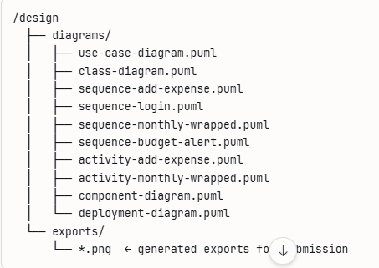

Problem 22- Project Structure Creation in PlantUML
Project Name: Pennywise – Expense Tracker
Structure of .puml files organized by UML model:
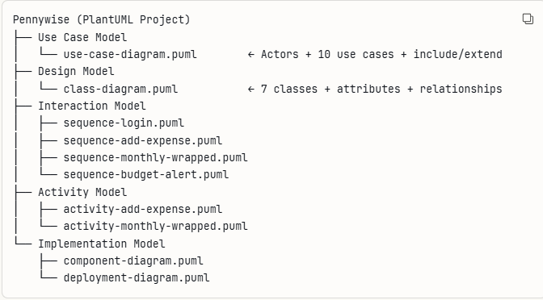
Naming Conventions Used:
- Files named in kebab-case (e.g., sequence-add-expense.puml)
- Class names in PascalCase (e.g., ExpenseService)
- Attributes and methods in camelCase (e.g., totalSpent)
- Diagram titles added at top of every file using title keyword
Problem 23: Actors Identification
Three actors were identified for the Pennywise system:
UPI User – The primary actor. A person who uses the app to record expenses, set budgets, and view spending insights.
Admin – Manages the system, handles user accounts, and monitors application health.
System – An internal actor that performs automated tasks like sending budget alerts and generating Monthly Wrapped reports.
Problem 24: Use Case Definition
The following 10 core use cases were defined:
UC ID | Use Case | Actor
UC-01 | Register / Login | UPI User
UC-02 | Add Expense | UPI User
UC-03 | Edit / Delete Expense | UPI User
UC-04 | Categorize Expense | UPI User
UC-05 | Set Monthly Budget | UPI User
UC-06 | View Dashboard | UPI User
UC-07 | View Monthly Wrapped | UPI User
UC-08 | Generate Report | UPI User
UC--09 | Send Budget Alert | System
UC-10 | Manage Users | Admin

Problem 25: Use Case Relationships
Include Relationships (one use case always requires another):
- UC-02 Add Expense includes UC-04 Categorize Expense — every expense must have a category
- UC-01 Register/Login includes Validate Credentials — login always triggers validation
- UC-06 View Dashboard includes UC-08 Generate Report — dashboard always loads summary data
Extend Relationships (one use case optionally extends another):
- UC-07 View Monthly Wrapped extends UC-06 View Dashboard — user can optionally open Wrapped from dashboard
- UC-05 Set Monthly Budget extends UC-09 Send Budget Alert — alert is triggered only when spending crosses the limit
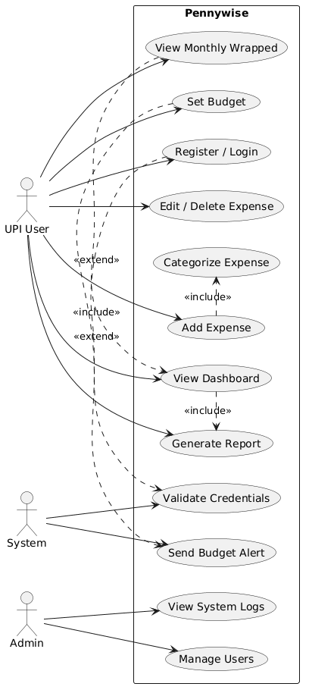

Problem 27: Class Identification
The following key classes were identified for the Pennywise system:
Class | Description
User | Represents a registered user of the application
Expense | Represents a single expense entry recorded by the user
Category | Represents the classification of an expense
Budget | Represents the monthly spending limit set by the user
MonthlyWrapped | Represents the visual monthly spending summary
Report | Represents the generated monthly expense report
Notification | Represents alerts sent when budget limits are crossed

Problem 28: Class Attributes and Methods
User
- Attributes: userId, name, email, passwordHash, createdAt
- Methods: register(), login(), logout(), getProfile()
Expense
- Attributes: expenseId, amount, description, date, categoryId
- Methods: addExpense(), editExpense(), deleteExpense(), getExpensesByMonth()
Category
- Attributes: categoryId, name, icon, colorCode
- Methods: getAll(), assignToExpense()
Budget
- Attributes: budgetId, monthYear, limitAmount, spentAmount
- Methods: setBudget(), checkExceeded(), getRemainingAmount()
MonthlyWrapped
- Attributes: wrappedId, month, year, topCategory, totalSpent, insights
- Methods: generate(), display()
Report
- Attributes: reportId, generatedAt, month, totalExpenses
- Methods: generate(), export()
Notification
- Attributes: notificationId, message, type, sentAt
- Methods: sendAlert()
Problem 29: Class Relationships
Association (general use relationship):
- User → Expense : A user records many expenses
- User → Budget : A user sets many budgets
- User → Report : A user generates many reports
Aggregation (whole-part, part can exist independently):
- MonthlyWrapped → Expense : Monthly Wrapped is built from many expenses, but expenses exist independently
- Report → Expense : A report includes many expenses, but expenses exist independently
Inheritance (is-a relationship):
- No inheritance used in the current scope — all classes are independent entities suited to the simple single-user nature of Pennywise
Dependency:
- Budget → Notification : Budget triggers a Notification when the spending limit is exceeded
- Expense → Category : Every Expense depends on a Category for classification
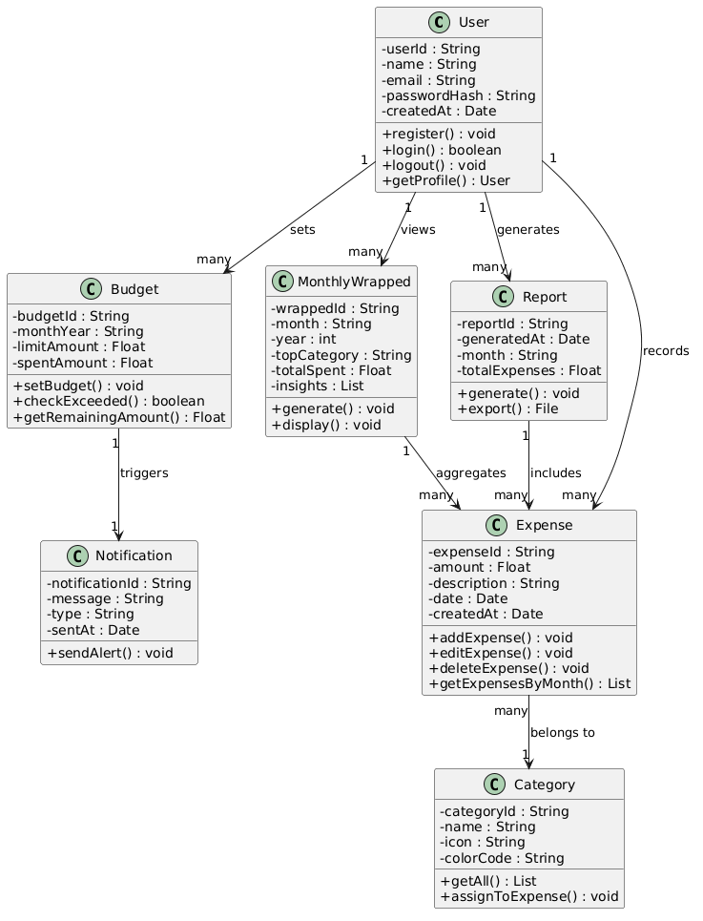

Problem 30: Sequence Diagrams Creation
Four critical sequence diagrams were created for the Pennywise system covering the most important user flows:
SD ID | Diagram Name | Purpose
SD-01 | User Login | Shows authentication flow
SD-02 | Add Expense | Shows core expense recording flow
SD-03 | Generate Monthly Wrapped | Shows wrapped generation flow
SD-04 | Set Budget and Alert | Shows budget monitoring flow

Problem 31: Object Interactions Documentation
SD-01: User Login The User interacts with the UI which passes credentials to AuthController. AuthController calls AuthService to validate, which queries the Database for the user record and verifies the password hash. On success, an auth token is returned and the user is redirected to the Dashboard.
SD-02: Add Expense The User fills the expense form on the UI. The UI sends data to ExpenseController, which fetches available categories from CategoryService. Once the user selects a category, ExpenseService saves the expense to the Database and updates the dashboard totals. BudgetService is also triggered to check current spending against the set limit.
SD-03: Generate Monthly Wrapped The User requests the Monthly Wrapped from the UI. WrappedController calls ExpenseService to fetch all expenses for the selected month from the Database. WrappedService then calculates total spent, identifies the top category, compares with the previous month, and builds the visual insights. The final wrapped data is sent back to the UI for display.
SD-04: Set Budget and Alert The User sets a monthly budget limit via the UI. BudgetController passes the data to BudgetService which saves it to the Database. Later, when an expense is added, BudgetService checks the total spent against the limit. If spending crosses 90% or 100%, NotificationService is triggered to send the appropriate alert to the user.

Problem 32: Alternative Flows
SD-01: User Login
- If credentials are invalid → AuthService returns failure → UI displays "Invalid credentials" error message
- If user does not exist → Database returns null → UI prompts user to register
SD-02: Add Expense
- If any field is left empty → ExpenseController returns validation error → UI highlights the missing field
- If Database save fails → ExpenseService returns error → UI shows "Could not save expense, try again"
SD-03: Generate Monthly Wrapped
- If no expenses exist for the selected month → WrappedService returns empty data → UI displays "No expenses recorded this month"
- If wrapped was already generated → System loads cached data instead of regenerating
SD-04: Set Budget and Alert
- If budget is already set for the month → BudgetService overwrites the existing limit after user confirmation
- If spending is below 90% of limit → No alert is triggered, system continues normally
Sequence Diagram 1 — User Login
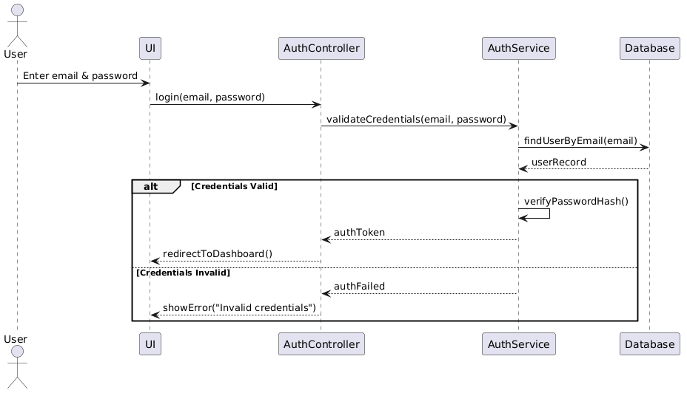

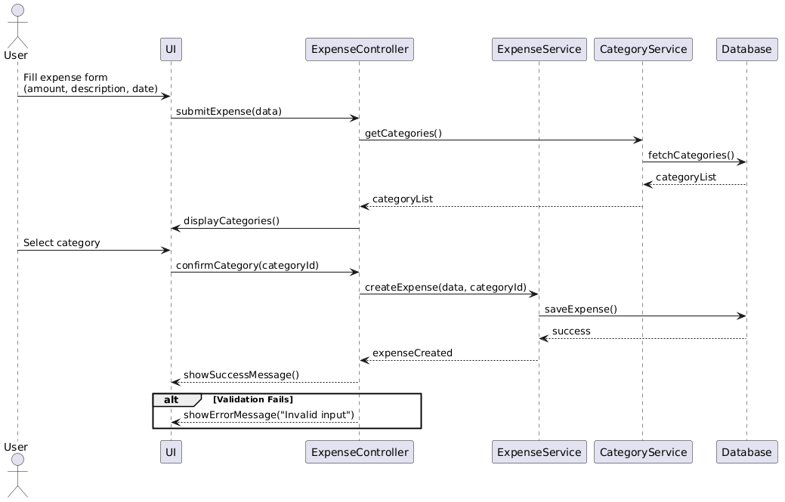
Sequence Diagram 2 - Add Expense

Sequence Diagram 3 — Generate Monthly Wrapped
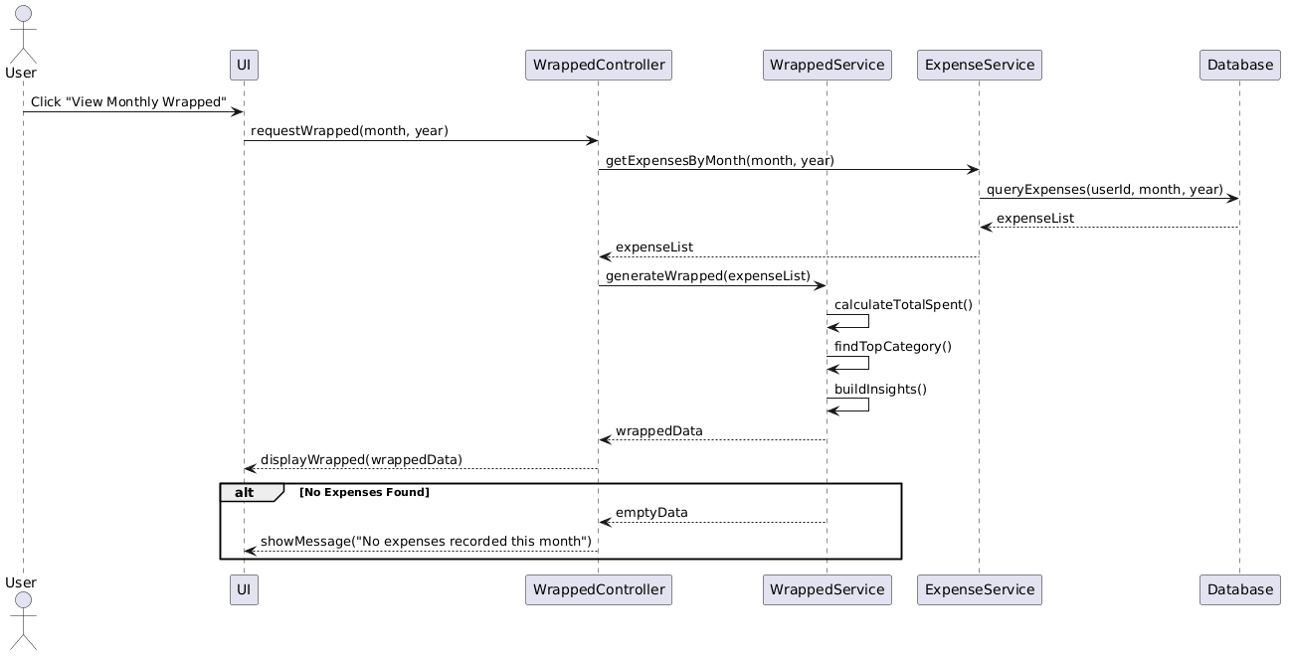

Sequence Diagram 4 - Set Budget & Alert
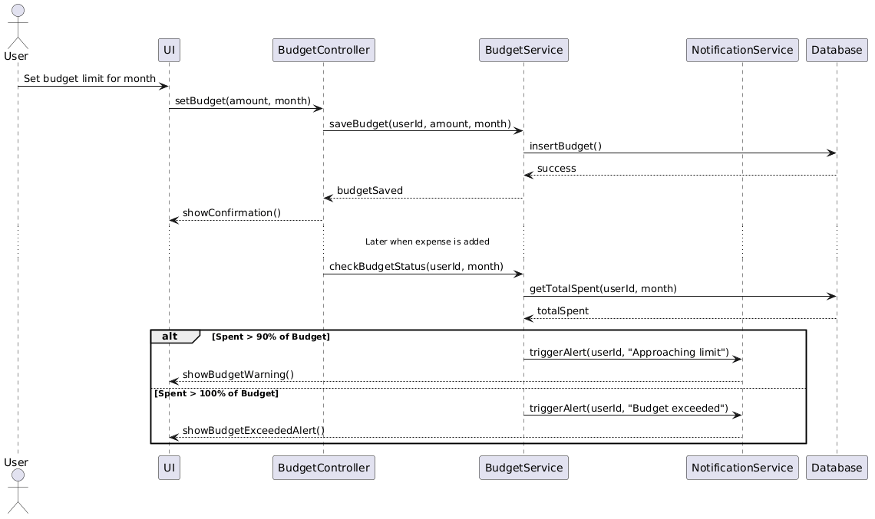

33-34: Activity Diagrams Creation & Workflow Documentation
This activity diagram documents the complete workflow when a user adds a new expense. The flow begins when the user opens the Add Expense screen and enters the required details. A decision point checks if all fields are valid. If validation fails, an error is shown and the process stops. If valid, the expense is categorized and saved. Two parallel activities then run simultaneously — budget status is checked (triggering an alert if exceeded) and the Monthly Wrapped data is updated. A success message is shown at the end.
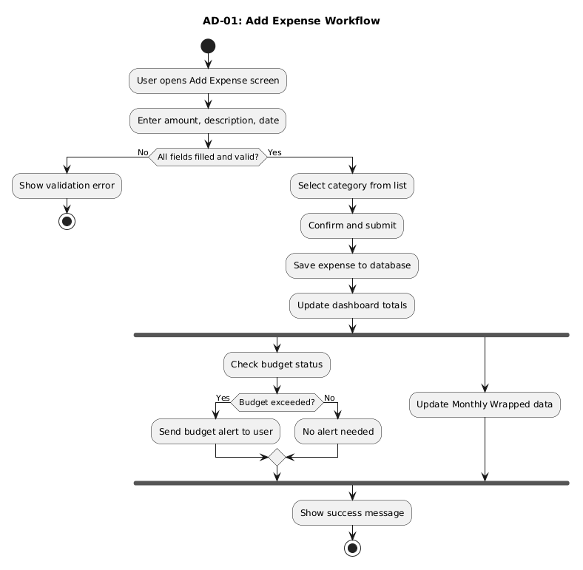
AD-02: Monthly Wrapped Generation Workflow
This activity diagram documents the workflow for generating the Monthly Wrapped summary. The process begins when the user navigates to the Monthly Wrapped screen. The system first checks if a wrapped report already exists for the selected month. If it does, cached data is loaded directly. If not, the system fetches all expenses for that month. If no expenses are found, a "No data available" message is shown. Otherwise, three parallel processes run — calculating total spent, identifying the top spending category, and comparing with the previous month. Once all three complete, the system builds the visual insights, saves the generated wrapped to the database, and displays it to the user.
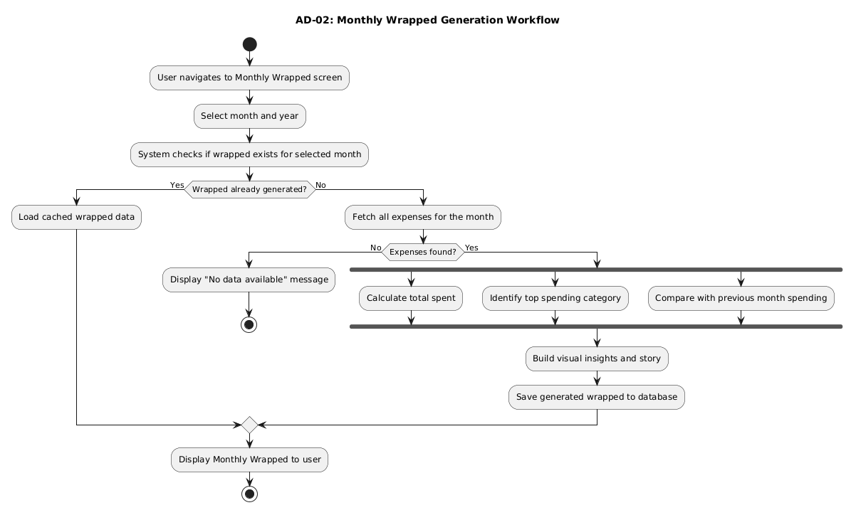
Problem 35: Component Diagram
The component diagram shows the internal architecture of Pennywise divided into four layers. The Presentation Layer contains all UI screens the user interacts with. The Application Layer holds controllers that handle user requests and route them to the correct service. The Service Layer contains the business logic for each feature. The Data Layer consists of repositories that communicate directly with the local SQLite database. Each layer only communicates with the layer directly below it, keeping the architecture clean and maintainable.
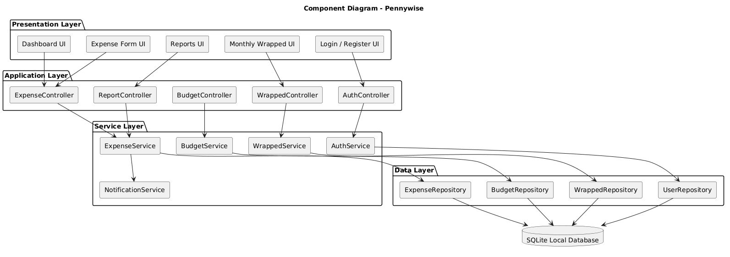

Problem 36: Deployment Diagram
The deployment diagram shows how Pennywise is physically deployed. Since it is a standalone desktop application, everything runs on the user's local machine. The Desktop Application node contains the UI layer, the application logic layer, and the local data access layer. All data is stored in a local SQLite database file on the same machine — no internet connection or external server is required. A separate Developer/CI node represents the GitHub repository and GitHub Actions pipeline used by the team for version control and automated testing during development.
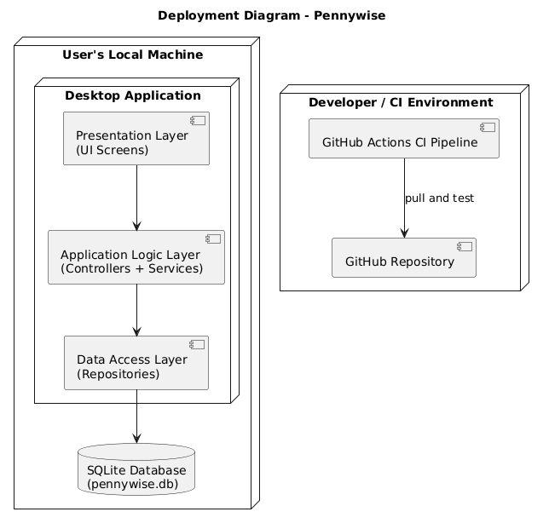
Problem 37: Design Document
Design Decisions and Justifications:
1. Layered Architecture Pennywise follows a 4-layer architecture — Presentation, Application, Service, and Data. This separation ensures each layer has a single responsibility, making the codebase easier to maintain, test, and extend in the future.
2. Local SQLite Database Since Pennywise is a standalone single-user desktop application with no internet dependency, SQLite was chosen as the database. It is lightweight, requires no separate server setup, and is well suited for academic project scope.
3. PlantUML for Design Diagrams PlantUML was selected as the CASE tool because it is free, text-based, and integrates easily with GitHub. Diagrams are stored as .puml files and version controlled alongside the source code, ensuring design and implementation stay in sync.
4. Manual Expense Entry Only Automatic UPI import was deliberately kept out of scope. Manual entry keeps the system simple, avoids third-party API dependencies, and is achievable within the academic semester timeline.
5. Monthly Wrapped as Core Feature The Monthly Wrapped module was designed as a separate service (WrappedService).This gives it an independent workflow and makes it easier to enhance visually in future iterations without affecting report generation.

Exercise 3: Agile Project Setup

